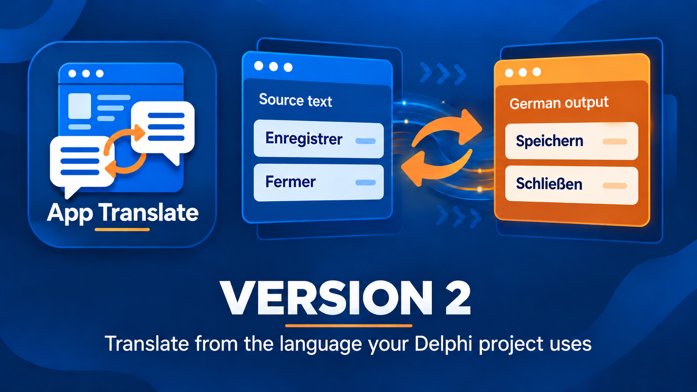

Delphi App Translation Studio User Guide
Create, review, and deploy offline language packs
Version 2 | Last changed 7 October 2026

Contents

Choose your starting path 3
Set up a new application 3
Review and correct translations 4
Continue in Maintenance Studio 5
Connect the runtime in Delphi 6
Test the running application 7
Recover from a Safety Backup 7
Resolve common problems 7

Choose your starting path
Delphi App Translation Studio prepares offline language packs for a Delphi VCL or FireMonkey application. Use the Setup Wizard for a first translation. Use the Maintenance Studio to reopen saved work, correct text, add languages, or deploy updated packs. People using the finished application do not need an internet connection to switch languages.
The source language is the language already written in the saved Delphi project. A target language is one you want the application to display. A development catalog is an editable record of translations. A runtime pack is the validated JSON file that the application reads. Saving a catalog does not export or deploy a runtime pack.

Before you begin
- Save the Delphi project and forms in RAD Studio. Know which language the saved text uses.
- Have a DeepL or Google Cloud Translation API key if you want automatic translations. Provider requests may incur charges.
- Know where the executable runs. Separate installed, portable, network, or USB folders can be added on the Wizard Deployment page.
- Close the running target application before a build or executable deployment. The Wizard makes a safety backup before final processing.

Set up a new application
From the start screen choose Run Setup Wizard. The eight steps stay visible on the left. You can revisit a completed step until final processing begins. The Wizard then handles backup, translation, review, validation, export, and preparation in order.
1. Welcome explains what the Wizard will prepare and which files it leaves under your control.
2. Delphi Project opens the .dproj or .dpr file. Automatic chooses between new and existing translation work. Create New Translation and Update Existing Translation let you direct that choice.
3. Deployment shows detected build-output folders. Add another application folder only if you want that copy updated. Executable replacement has its own authorization control.
4. Languages asks for the language in the saved source files and a different target language.
5. Translation Service offers DeepL and Google Cloud Translation. DeepL also asks for API Free or API Pro. Enter or use a saved key and choose Test Connection.
6. Scan Project reads the saved forms and source text. Review the sample and counts before choosing Next.
7. Review and Authorize checks your choices and the required safety conditions. Begin Final Processing starts the backup and remaining work.
8. Process and Finish displays progress. Localization Review opens during this pass; close it when your review is complete so validation, export, and kit preparation can continue.
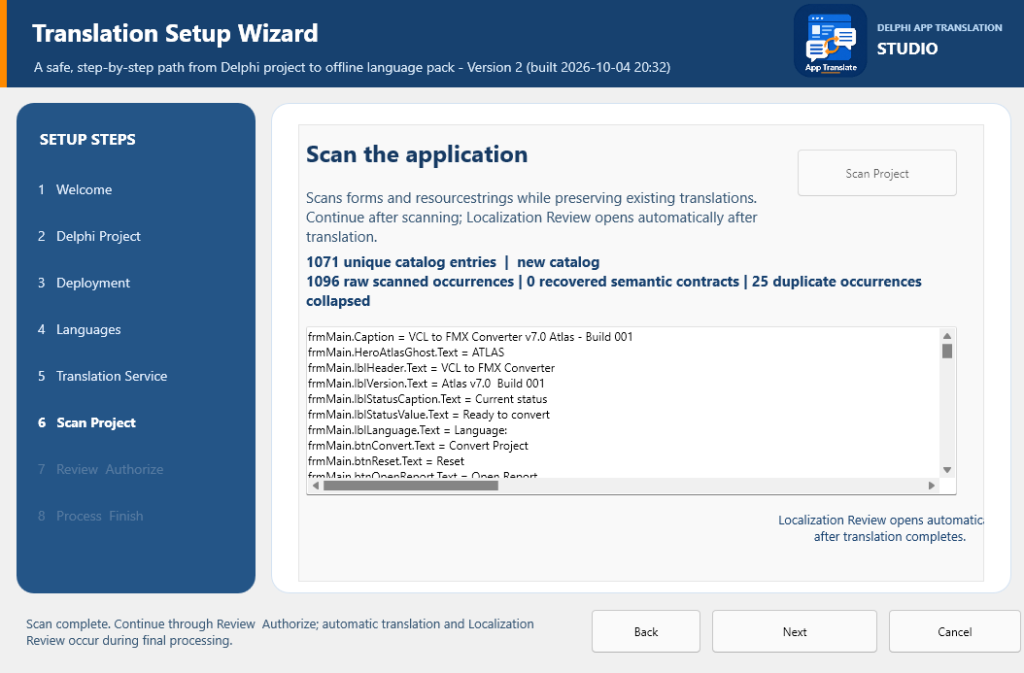
The Wizard scan page shows the text it found. Check the project and source language before choosing Next. Counts vary by application.
The Wizard first creates a timestamped ZIP safety backup. It then translates unresolved entries, opens Localization Review, validates the catalog, exports the runtime pack, prepares a project-local dependency and component kit, and deploys packs to available build outputs. It does not silently rewrite target Pascal, DPR, DPROJ, DFM, or FMX files.
After successful processing, Add more languages opens language work, Open Maintenance opens the continuing workspace, and Return to start goes home. Deploy to App Folder is available only after processing succeeds, for another folder you select manually.

Review and correct translations
Localization Review lets you inspect wording and layout. Check short labels, punctuation, placeholders such as %s, keyboard shortcuts, and long text that may wrap differently. For right-to-left languages, test the running forms as well as the words.
In Maintenance Studio, the Translate page lists entries on the left and shows source and translated text on the right. Select an entry, correct the target text, choose Apply Translation, and Save. Mark Reviewed records that a person checked the wording. Approve is a separate decision. Details and Tools contains optional settings; ordinary corrections can stay on the main page.
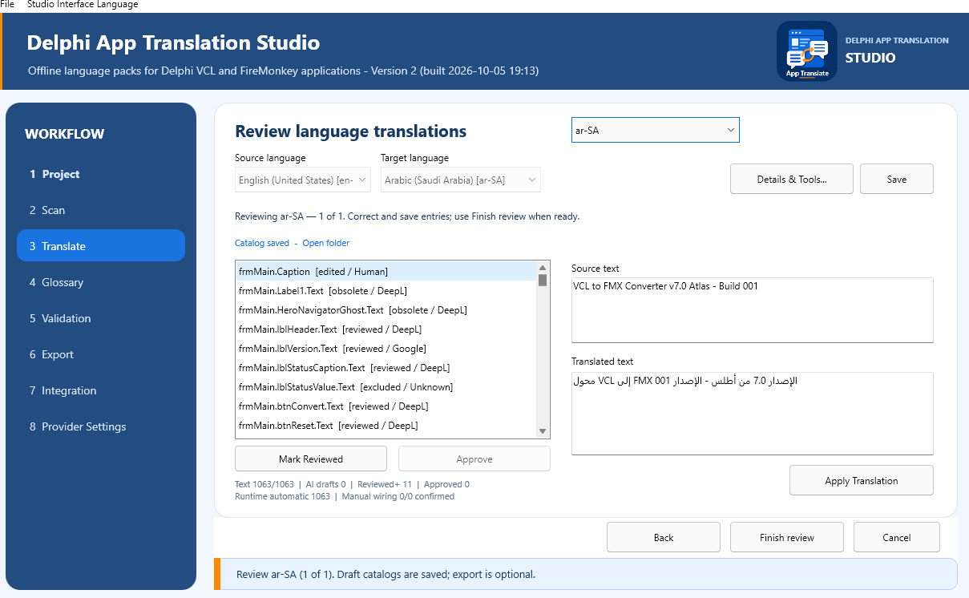
Source and translated text appear side by side. This example shows a saved Arabic catalog; your project and language will differ.

Continue in Maintenance Studio
Open Maintenance Studio from the start screen and select the Delphi project. The left rail has Project, Scan, Translate, Glossary, Validation, Export, Integration, and Provider Settings. These are work areas, not eight steps that must always be repeated. Reopening a project can resume its saved catalogs.
Project confirms the saved source language. Scan refreshes entries after project text changes. Translate edits catalogs or adds languages. Glossary stores preferred terminology. Validation checks whether a catalog can be exported. Export reviews packs and destinations. Integration prepares the dependency and component kit. Provider Settings manages the online translation connection.

Add languages over several sessions
1. Open the project and scan if saved source files have changed.
2. On Translate choose Add languages. Select one or several new target languages, then choose Translate Selected. Existing catalogs are preserved and do not need to be selected again.
3. Watch the inline progress and batch results. Several languages can take a few minutes while provider requests complete.
4. Review and save the catalogs. From Language review complete choose Add more languages, Review saved languages, Validate saved languages, or Finish without exporting.
5. When ready, validate and open Export. Review the ready languages and every destination, then choose Export and deploy. Return later to add another language and repeat the export.
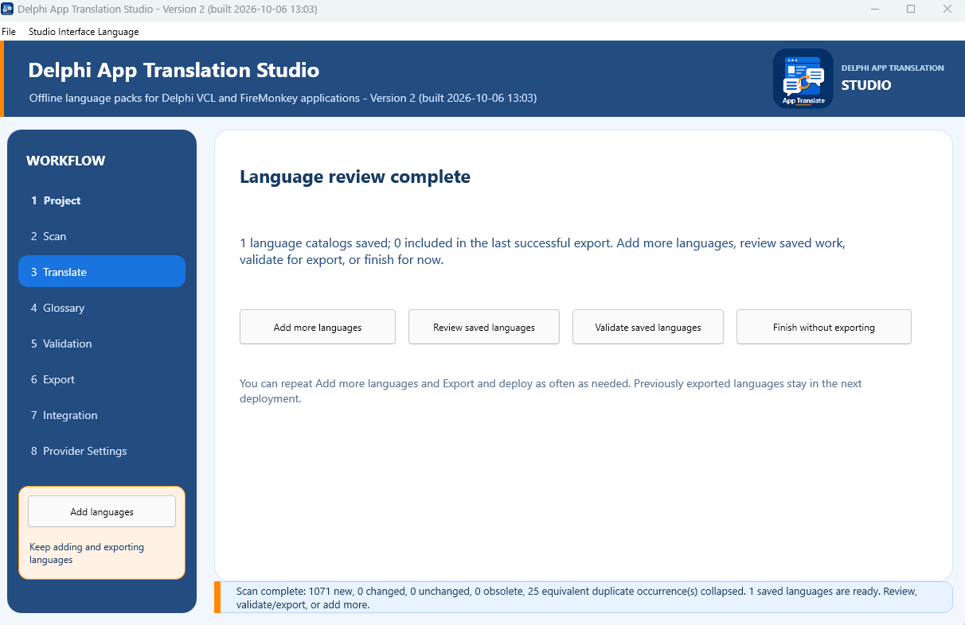
After a review, choose whether to add another language, revisit saved work, validate, or leave the drafts for later.

Validate and export
Validation checks required text, placeholders, accelerator keys, source changes, duplicate keys, and catalog information. An error must be corrected for that language before export. A warning asks for review but does not itself block export. In a batch, languages without errors can be exported while languages with errors stay saved as drafts.
The Export page shows validated languages and destinations before writing anything. Confirm the list carefully. Export replaces deployed language-pack folders with the validated set and the original-language pack. It updates available executable folders and the project Localization\Languages folder used for later builds. Archived portable exports are not changed.

Connect the runtime in Delphi
On Integration choose Prepare or Update Dependencies. The Studio places managed source under dependencies\DelphiAppTranslation\source and prepares a verified component kit. In RAD Studio, add that folder to the Delphi Compiler Search path for every configuration and platform you distribute. The Studio uses a temporary path for builds it starts; it does not edit your DPROJ setting.
Install the matching DAT design package through Component > Install Packages > Add. Place one language manager and one connected language selector on the primary form. VCL uses TDATVCLLanguageManager and TDATVCLLanguageComboBox. FireMonkey uses TDATFMXLanguageManager and TDATFMXLanguageComboBox. In the Object Inspector, set ApplicationId to the application ID, SourceLanguage to the language of the saved project, and leave LanguagesFolder as Localization\Languages. Set the selector's LanguageManager property to the manager.

Test the running application
1. Build each platform and configuration you distribute.
2. Run the executable from an updated folder and confirm Localization\Languages is beside it.
3. Switch to a target language and back to the source language. Close and reopen the application to confirm its choice persists.
4. Check forms, menus, dialogs, dynamic messages, long labels, and right-to-left layouts. Correct text in the Studio and export again if needed.

Recover from a Safety Backup
From the start screen choose Recover from Safety Backup. Select a Studio ZIP safety backup, inspect its preview, and choose an empty destination folder. The recovery screen rejects unsafe archive paths and does not overwrite the original project. Open the restored project in Delphi after checking that it is the copy you intended.

Resolve common problems
- No language appears in the running application: check Localization\Languages beside that exact executable and confirm the selector is connected to the manager.
- Export is unavailable: open Validation, select an affected language, inspect a specific error, correct and save it, then validate again.
- Text is clipped or awkward: review the proposed layout and test the running form. A proposal does not replace visual inspection.
- An old translation reappears: confirm the project and source-language pair, scan saved source changes, and export the corrected catalog again.

